TN5250J for WDSCi 7.0/RDP 8.0+

Overview

With TN5250J for WDSCi 7.0/RDP 8.0+ you can run a 5250 Emulation in an own view/editor (TN5250J Sessions) within WDSCi 7.0/RDP 8.0+. You must no longer leave the IDE, if you need a 5250 session. (See section “Create a session”)

You can start SDA/RLU in an own view/editor (TN5250J Designer) within WDSCi 7.0/RDP 8.0+ for a source physical file member with type DSPF, MNUDDS or PRTF in view “Remote Systems” just by selecting the specific menu item. In order to use this feature the system value QRMTSIGN has to be set to *VERIFY. (See section “Create a designer session”)

With an user defined option in PDM “Work with member - WRKMBRPDM” you can start the LPEX-Editor, Screen Designer or Report Designer. (See section “Start LPEX-Editor, Screen Designer or Report Designer from within PDM”). Furthermore you can start the Eclipse Compare/Merge Editor for comparing/merging source physical file members. (See section “Start Eclipse Compare/Merge Editor from within PDM”).

TIP

When pressing F1 or SHIFT-F1 (means F13) in a TN5250J session the eclipse help view will automatically be opened. You can prevent this, if you assign in the TN5250J keyboard settings the F1 function to ALT-F1 and the F13 function to ALT-SHIFT-F1.

Manual

Minimal session size

Select menu item “Window/Preferences”.

In the tree on the left side expand the entry “TN5250J”.

Select “Minimal session size”

You see this.

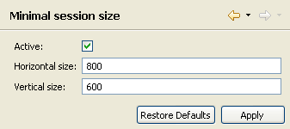

Here you can specify a minimal size for a session. If the size of the session falls below the specified minimal size a scrollbar appears and you can scroll within the session by scrollbar or by keyboard. Press “Ctrl-Alt-Arrow Up” to scroll up. Press “Ctrl-Alt-Arrow Down” to scroll down. Press “Ctrl-Alt-Arrow Left” to scroll left. Press “Ctrl-Alt-Arrow Right” to scroll right.

Enter the values for a minimal session size and click “Apply”.

Define session defaults

Select menu item “Window/Preferences”.

In the tree on the left side expand the entry “TN5250J”.

Select “Session defaults”

You see this.

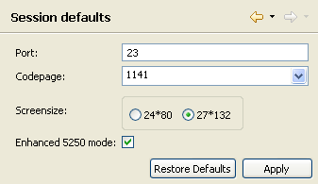

Enter the default values for the sessions and click “Apply”.

Create a session

Right-click the subsystem “TN5250J” and select “New session”.

The following window appears.

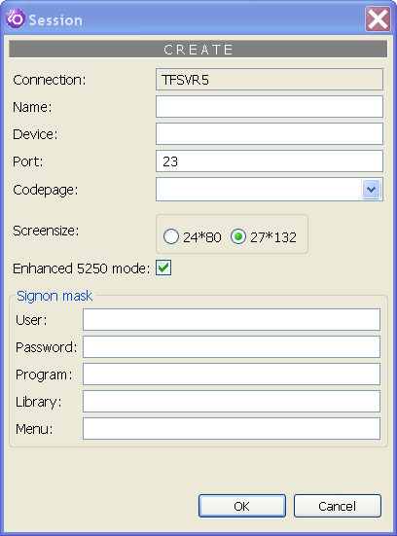

Fill out the fields and click “OK”.

Repeat this step, if you want to create more sessions for the connection.

After creating the sessions the view “Remote Systems” looks like this.

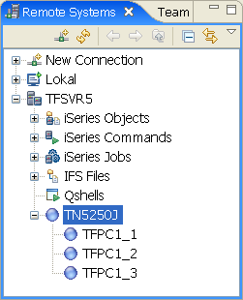

To change, delete or display the session parameters right-click the session and select the specific menu item.

Start a session

To start a session double-click the session.

The view/editor “TN5250J Sessions” appears as following.

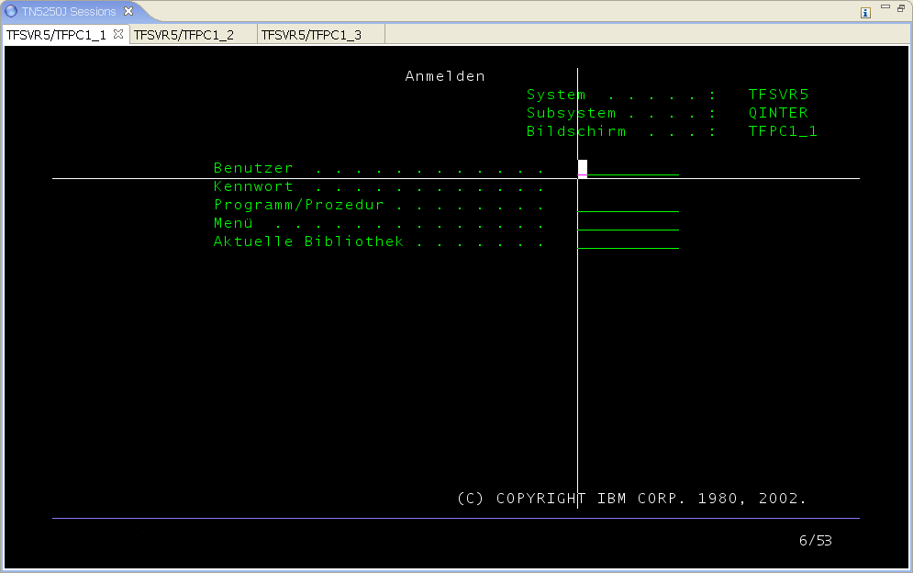

Every session appears in its own tab item. To toggle between the sessions click the specific tab item or press “Ctrl-Arrow Up” to select the next session or press “Ctrl-Arrow Down” to select the previous session.

To close a session click on the close icon on the tab item .

Start a multi session

At first start a session as described in section “Start a session”. The device in the session definition of the selected session has to be blank. If you have specified a device, then you can not start a multi session for such a session definition.

To start a multi session click on icon in the tool bar of view/editor “TN5250J Sessions”. Click the icon again, to start another multi session. You can start up to four multi sessions.

The view/editor “TN5250J Sessions” could appear like this.

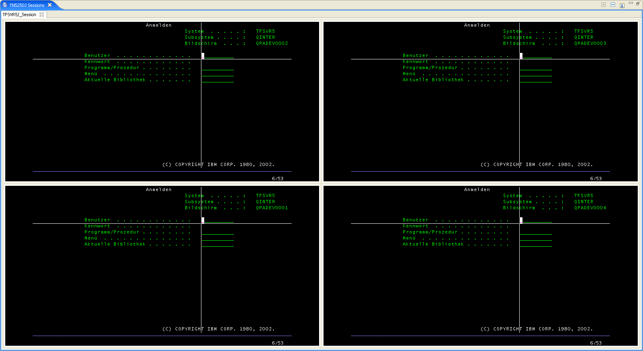

To toggle between the multi sessions click the specific multi session or press “Alt-Arrow Up” to select the next multi session or press “Alt-Arrow Down” to select the previous multi session.

To close a multi session click on icon in the tool bar of view/editor “TN5250J Sessions”. The multi session with the current focus will be closed.

Create a designer session

Right-click the subsystem “TN5250J” and select “New designer session”.

The following window appears.

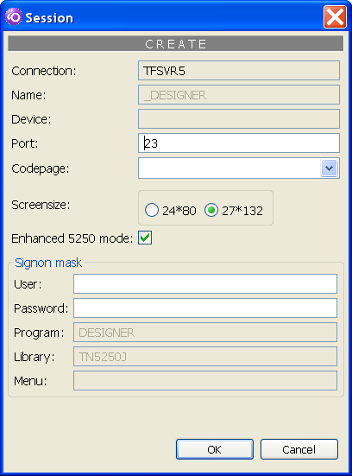

Fill out the fields and click “OK”. In comparison to a normal session a designer session requires user and password. The password will be stored encrypted. Although you can start several designer sessions you have to define just one designer session.

After creating the designer session the view “Remote Systems” looks like this.

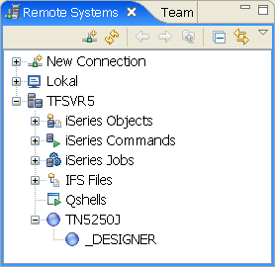

To change, delete or display the designer session parameters right-click the designer session and select the specific menu item.

Start a designer session

To start a designer session right-click in view “Remote Systems” a source physical file member with type DSPF, MNUDDS or PRTF and select menu item “TN5250J Designer” in menu group “Open with” or “Browse with”.

The view/editor “TN5250J Designer” appears as following.

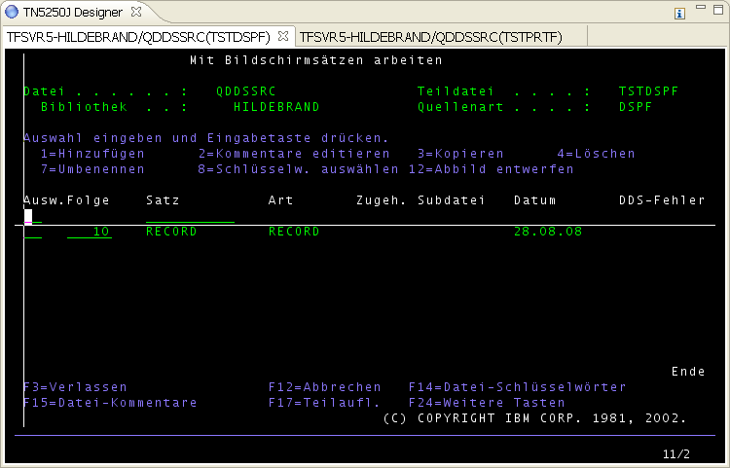

Every designer session appears in its own tab item. To toggle between the designer sessions click the specific tab item or press “Ctrl-Arrow-Up” to select the next designer session or press “Ctrl-Arrow-Down” to select the previous designer session.

To close a designer session click on the close icon on the tab item .

After designing you can leave SDA/RLU to proceed as normal. The following screen appears.

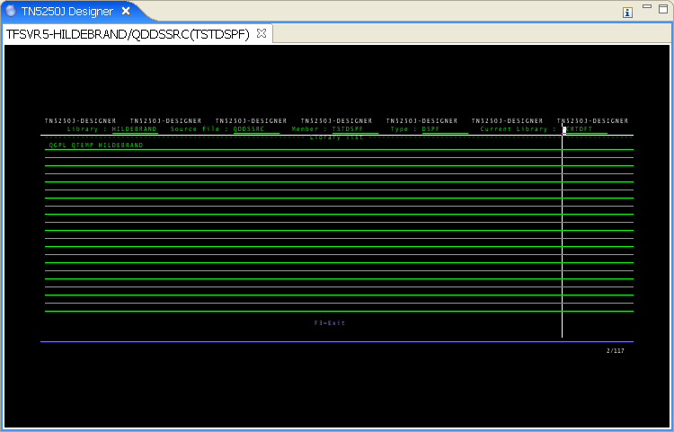

If you press “Enter” SDA/RLU will be started again. If you press “F3” the session will be closed and the tab item disappears.

If you start the designer in browse mode, then the original source will be copied to library QTEMP in file QTN5250J. After this SDA/RLU will be started with library QTEMP and source file QTN5250J. If you make now changes with SDA/RLU, then these changes have no effect to the original source.

Start LPEX-Editor, Screen Designer or Report Designer from within PDM

Start PDM by entering command STRPDM.

Select menu item “9 = Work with user defined options”.

Select the file for your user defined options and press enter.

Press F6 to create a new user defined option.

In field “User defined option” enter a value. For example “XY”.

In field “Command” enter
CALL PGM(ISPHERE/HANDLER) PARM('EDITOR' '&L' '&F' '&N' '*OPEN')
for open LPEX-Editor, Screen Designer or Report Designer in modify mode.

In field “Command” enter
CALL PGM(ISPHERE/HANDLER) PARM('EDITOR' '&L' '&F' '&N' '*BROWSE')
for open LPEX-Editor, Screen Designer or Report Designer in browse mode.

Press enter to store the user defined option.

Run the command “Work with members – WRKMBRPDM”.

Next to a physical file member enter your user defined option.

The LPEX-Editor, Screen Designer or Report Designer will be started.

Start Eclipse Compare/Merge Editor from within PDM

Start PDM by entering command STRPDM.

Select menu item “9 = Work with user defined options”.

Select the file for your user defined options and press enter.

Press F6 to create a new user defined option.

In field “User defined option” enter a value. For example “XY”.

In field “Command” enter
CALL PGM(ISPHERE/HANDLER) PARM('COMPARE' '&L' '&F' '&N')

Press enter to store the user defined option.

Run the command “Work with members – WRKMBRPDM”.

Next to a physical file member enter your user defined option.

The Eclipse Compare/Merge Editor will be started.

Activate/Deactivate eclipse key bindings

When a TN5250J session has focus, then eclipse key bindings are deactivated. This is necessary, because the key strokes have to be send to the 5250 emulation. Now by pressing Ctrl+F12 in a TN5250J session you can activate/deactivate eclipse key bindings. For example if you want to change the perspective you can now press Ctrl+F12 to activate eclipse key bindings. Then press Ctrl+F8 for changing the perspective.

TIP

When pressing F1 or SHIFT-F1 (means F13) in a TN5250J session the eclipse help view will automatically be opened. You can prevent this, if you assign in the TN5250J keyboard settings the F1 function to ALT-F1 and the F13 function to ALT-SHIFT-F1.

Miscellaneous

To get general informations about the TN5250J emulator visit the site http://tn5250j.sourceforge.net/

